**Software Architecture and Design**

**Lab Manual**

**Basic Programming Practice – Week 1 Lab**



**Made By:**

**M Faizan Khan**

**Session: Fall 2022**

**School Of Software Engineering and Technology (South China Normal University, China)**

**Instructions**

* The purpose of this lab is to know the programming knowledge of the average students.
* **Programming Language:** You are supposed to use JAVA for following programming tasks.
* **Discussion:** You are allowed to do discussion about the following programs.
* **Submission Guidelines:** How to submit the lab I will guide you later.
* **Grading:** The following lab can be graded and marks will be counted towards your final score. So, it is advised to each and every student to take following tasks seriously.

# Lab Task 1

Write a Java program that calculates the daily wage of a factory worker. The daily wage of the worker is no. of hours worked* hour rate. The number of hours worked in a day and the hour rate are entered from the user.

If the hours worked in a day exceeds 8. Then the worker receives 1.5 times hour rate for every hour worked over 8.

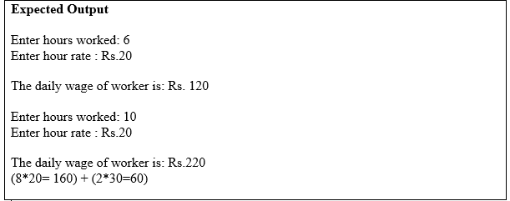

# Lab Task 2

Suppose we need to decide what kind of vacation to take based on a yearly work bonus:

* If the bonus is less than $5,000, we go to Dream Land Park, Houston.
* if the bonus is less than $9,000 and greater than or equal to $5,000, we go to Beijing
* if the bonus is $9,000 or greater than this , we go to Hainan.

Write pseudo code and draw a flow chart to make decision.

# Lab Task 3

Write and execute the following code, Notice the order of constructer and destructor:

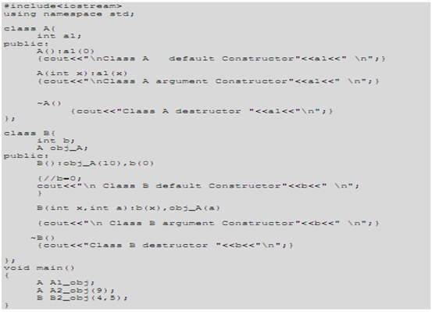

Now, add the following copy constructor to the class A, and observe the difference in output:

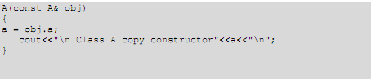

# Lab Task 4

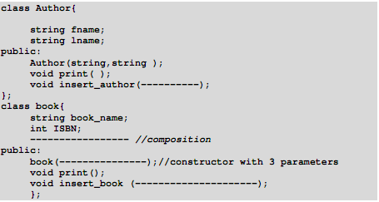Giving the author class and the book class, answer the questions below:

Write the implementation for class author and book.

o Write main program that will Write a driver program that test the class as follow:

1. Define an array of 3 elements of type book.

2. Insert values for these 3 books.

3. Print values of these 3 books in a table.

Write a friend function for class book that will search for a given book according to its ISBN. If it is found you will print the information of that book (book_name, ISBN, author), if not it is not found print "Not found".